Adding support for stm32F303RETx

This document include the performed work

Index

Configuring Git 2

Make a fork in GitHub 2

Clone the fork, and make a branch where we work 2

Make CubeMX project for stm32F401VETx 3

# Configuring Git

## Make a fork in GitHub

The first is a prolific work, not much to say, a simply fork.

## Clone the fork, and make a branch where we work

Sebas@yoyiPC MINGW64 /d/git

$ git clone https://github.com/sebastianoscarlopez/Marlin4ST.git

Cloning into 'Marlin4ST'...

remote: Counting objects: 3284, done.

remote: Total 3284 (delta 0), reused 0 (delta 0), pack-reused 3284

Receiving objects: 100% (3284/3284), 82.37 MiB | 358.00 KiB/s, done.

Resolving deltas: 100% (1825/1825), done.

Checking out files: 100% (2714/2714), done.

Sebas@yoyiPC MINGW64 /d/git

$ cd Marlin4ST/

Sebas@yoyiPC MINGW64 /d/git/Marlin4ST (master)

$ git checkout -b support-STM32F303RE

Switched to a new branch 'support-STM32F303RE'

Sebas@yoyiPC MINGW64 /d/git/Marlin4ST (support-STM32F303RE)

$ git push --set-upstream origin support-STM32F303RE

Total 0 (delta 0), reused 0 (delta 0)

To https://github.com/sebastianoscarlopez/Marlin4ST.git

* [new branch] support-STM32F303RE -> support-STM32F303RE

Branch support-STM32F303RE set up to track remote branch support-STM32F303RE from origin.

# Make CubeMX project for stm32F401VETx

The project Marlin4ST is based on CubeMX, but don’t include de project, just the generated code by it. So before add support for other processors, I thinked would be useful have a project CubeMX with the configuration for the stm3232F401VETx

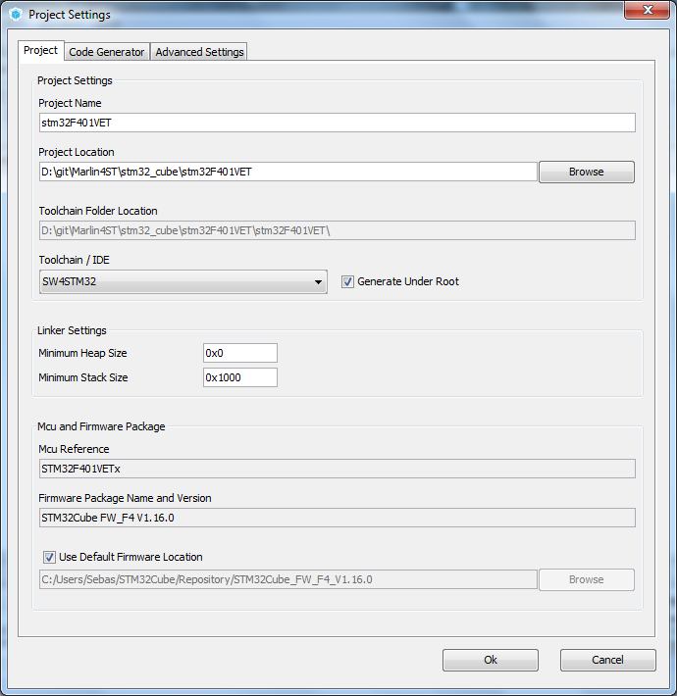

Change the heap and stack equal to the linker

